Revenue Driver Model - Corrected Comprehensive Report
Separate benchmark-calibrated models for Streaming Media and SaaS recurring revenue
Prepared: April 1, 2026
Overall confidence score: 78 / 100
Important disclaimer: The forecast horizon was extended to 24 months to address multi-cycle reactivation and truncated-window issues. Forecast confidence declines further out in time, especially beyond 12 months. Scenario bands should be interpreted as uncertainty bands, not precise statistical guarantees.

Executive Summary
The model has been comprehensively corrected in response to the independent audit. The most important structural change is the separation of the original blended framework into two independent models: one for streaming media subscriber economics and one for SaaS recurring-revenue economics. This separation removes cross-domain contamination and allows each model to use more defensible benchmark inputs, more appropriate state transitions, and domain-specific KPI logic.
The streaming model now uses subscriber-weighted ARPU, dynamic acquisition based on benchmark net-growth rates, segmented voluntary and involuntary churn, separate first-time and repeat reactivation pools, installed-base expansion, promotional contraction, pricing dynamics, billing-leakage scenarios, and explicit reactivation dampening. Streaming CAC was excluded because public evidence was not strong enough to estimate it credibly for the modeled business.
The SaaS model is now a benchmark-normalized archetype for the $1M-$3M ARR band. It includes independent CAC, CLV as a discounted gross-profit output, CLV/CAC as an output rather than an input, dynamic new-logo acquisition, installed-base expansion, contraction, segmented churn, reactivation, pricing uplift, and feedback loops that link churn to CAC and expansion to retention.
The corrected confidence scores are: Streaming 79/100, SaaS 76/100, combined framework 78/100. The lower score versus the prior 88/100 claim reflects a more honest assessment of remaining benchmark dependence and the exclusion of weakly supported metrics.

Model Scope and Exclusions
The corrected framework explicitly excludes metrics that do not meet acceptable confidence thresholds. Exclusion is treated as a strength, not a weakness: it prevents false precision.
Item | Status | Reason
Streaming CAC | Excluded | Public-source support was not strong enough to estimate company-specific streaming CAC defensibly without reintroducing circularity.
Seats / licenses / users factor | Excluded | No sufficiently defensible public-source dynamic was available for a shared seat-style KPI across both domains.

Streaming Model
The streaming model begins from observed rate-card MRR and converts it to effective collected MRR using a disclosed billing-leakage uncertainty band. Beginning subscribers are derived transparently from rate-card MRR divided by subscriber-weighted ARPU. Acquisition is dynamic and benchmark-linked rather than fixed. Reactivation is segmented by churn type, and repeat churners are tracked separately to avoid double counting.
Subscriber-weighted ARPU = 9.60, compared with a simple average of 8.78. Beginning subscribers = 12,026 / 9.60 = 1252.65. Billing leakage uses a base derivation of 15% decline exposure × 30.6% unrecovered = 4.59%, with low/base/high scenarios of 2.0%, 4.59%, and 8.0%.

Streaming Benchmark Table
platform | subs_millions | arpu | annual_sub_growth | notes
Netflix | 301.63 | 11.70 | 0.1590 | Subscriber base and global ARM 2024
Disney+ | 158.60 | 7.20 | 0.1190 | Q4 2024 subscribers and overall ARPU
WBD DTC | 116.90 | 7.44 | 0.2000 | Q4 2024 DTC subscribers and global ARPU

Streaming Monthly Model (24 months)
Month | Beginning Subs | ARPU | New Adds | Voluntary Churn Subs | Involuntary Churn Subs | Gross Churn Subs | Reactivated Voluntary | Reactivated Involuntary | Reactivated Repeat | Total Reactivations | Ending Subs | Gross Expansion MRR | Contraction MRR | Net Expansion MRR | Rate Card MRR | Effective MRR | ARR Run Rate | Net Churn Rate | Reactivation Dampening % | Leakage Applied | Tail Reactivation Reserve
1 | 1,252.65 | 9.58 | 77.18 | 46.58 | 12.04 | 58.62 | 0 | 0 | 0 | 0 | 1,271.20 | 60.81 | 36.95 | 23.86 | 12,175.14 | 11,616.30 | 139,681.90 | 0.0468 | 0 | 0.0459 | 2.69
2 | 1,271.20 | 9.63 | 73.06 | 46.35 | 12.01 | 58.36 | 4.66 | 5.42 | 0 | 10.08 | 1,295.97 | 67.61 | 28.75 | 38.86 | 12,482.52 | 11,909.57 | 143,381.11 | 0.0380 | 0.1727 | 0.0459 | 5.37
3 | 1,295.97 | 9.69 | 72.21 | 47.41 | 12.28 | 59.69 | 7.66 | 7.21 | 0 | 14.87 | 1,323.36 | 69.55 | 29.61 | 39.94 | 12,818.33 | 12,229.97 | 147,238.94 | 0.0346 | 0.2492 | 0.0459 | 8.07
4 | 1,323.36 | 9.74 | 71.66 | 48.48 | 12.56 | 61.04 | 10.72 | 8.10 | 0.0800 | 18.91 | 1,352.89 | 71.52 | 30.47 | 41.05 | 13,178.38 | 12,573.50 | 151,374.58 | 0.0318 | 0.3098 | 0.0459 | 10.83
5 | 1,352.89 | 9.80 | 72.21 | 49.62 | 12.85 | 62.48 | 11.91 | 8.50 | 0.1600 | 20.57 | 1,383.19 | 73.62 | 31.38 | 42.25 | 13,549.62 | 12,927.69 | 155,639.24 | 0.0310 | 0.3292 | 0.0459 | 13.27
6 | 1,383.19 | 9.85 | 72.48 | 50.75 | 13.15 | 63.89 | 13.16 | 8.65 | 0.2400 | 22.05 | 1,413.83 | 75.76 | 32.29 | 43.47 | 13,927.98 | 13,288.68 | 159,985.84 | 0.0303 | 0.3451 | 0.0459 | 15.77
7 | 1,413.83 | 9.83 | 72.46 | 51.88 | 13.44 | 65.32 | 14.47 | 8.82 | 0.3000 | 23.58 | 1,444.56 | 77.33 | 46.14 | 31.19 | 14,197.26 | 13,545.60 | 162,921.54 | 0.0295 | 0.3611 | 0.0459 | 18.33
8 | 1,444.56 | 9.88 | 72.40 | 53.01 | 13.73 | 66.74 | 15.81 | 9 | 0.3400 | 25.15 | 1,475.37 | 79.56 | 33.90 | 45.66 | 14,581.97 | 13,912.65 | 167,499.78 | 0.0288 | 0.3769 | 0.0459 | 20.94
9 | 1,475.37 | 9.94 | 72.55 | 54.14 | 14.03 | 68.17 | 17.18 | 9.19 | 0.3800 | 26.75 | 1,506.51 | 81.82 | 34.86 | 46.96 | 14,973.78 | 14,286.48 | 172,001.31 | 0.0281 | 0.3924 | 0.0459 | 23.61
10 | 1,506.51 | 10.00 | 73.15 | 55.29 | 14.32 | 69.62 | 18.58 | 9.38 | 0.4300 | 28.38 | 1,538.42 | 84.11 | 35.83 | 48.28 | 15,377.29 | 14,671.47 | 176,636.96 | 0.0274 | 0.4076 | 0.0459 | 26.33
11 | 1,538.42 | 10.05 | 74.59 | 56.48 | 14.63 | 71.11 | 19.53 | 9.57 | 0.4700 | 29.57 | 1,571.47 | 86.43 | 36.82 | 49.61 | 15,796.38 | 15,071.33 | 181,451.25 | 0.0270 | 0.4158 | 0.0459 | 29.11
12 | 1,571.47 | 10.11 | 76.58 | 57.70 | 14.95 | 72.65 | 20.52 | 9.76 | 0.5100 | 30.79 | 1,606.20 | 88.78 | 37.83 | 50.95 | 16,236.63 | 15,491.37 | 186,507.86 | 0.0266 | 0.4239 | 0.0459 | 31.94
13 | 1,606.20 | 10.09 | 78.96 | 58.99 | 15.28 | 74.27 | 21.54 | 9.96 | 0.5500 | 32.05 | 1,642.94 | 90.49 | 53.99 | 36.50 | 16,568.98 | 15,808.46 | 190,139.56 | 0.0263 | 0.4315 | 0.0459 | 32.51
14 | 1,642.94 | 10.14 | 81.86 | 60.36 | 15.64 | 76 | 21.96 | 10.18 | 0.5900 | 32.73 | 1,681.53 | 93.03 | 39.65 | 53.37 | 17,053.94 | 16,271.16 | 195,894.41 | 0.0263 | 0.4307 | 0.0459 | 33.15
15 | 1,681.53 | 10.20 | 84.59 | 61.79 | 16.01 | 77.80 | 22.42 | 10.40 | 0.6300 | 33.45 | 1,721.77 | 95.67 | 40.79 | 54.88 | 17,560.66 | 16,754.63 | 201,714.11 | 0.0264 | 0.4300 | 0.0459 | 33.85
16 | 1,721.77 | 10.26 | 86.89 | 63.28 | 16.39 | 79.67 | 22.91 | 10.64 | 0.6600 | 34.21 | 1,763.20 | 98.45 | 41.98 | 56.47 | 18,084.80 | 17,254.71 | 207,734.14 | 0.0264 | 0.4294 | 0.0459 | 34.57
17 | 1,763.20 | 10.31 | 88.64 | 64.80 | 16.79 | 81.59 | 23.43 | 10.90 | 0.6800 | 35 | 1,805.25 | 101.37 | 43.23 | 58.14 | 18,620.64 | 17,765.96 | 213,889.17 | 0.0264 | 0.4290 | 0.0459 | 35.33
18 | 1,805.25 | 10.37 | 89.83 | 66.34 | 17.19 | 83.53 | 23.96 | 11.16 | 0.7000 | 35.82 | 1,847.38 | 104.40 | 44.52 | 59.88 | 19,162.73 | 18,283.16 | 220,116.57 | 0.0264 | 0.4288 | 0.0459 | 36.12
19 | 1,847.38 | 10.35 | 90.66 | 67.88 | 17.58 | 85.46 | 24.51 | 11.43 | 0.7200 | 36.66 | 1,889.23 | 106.65 | 63.66 | 43 | 19,550.72 | 18,653.35 | 224,356.10 | 0.0264 | 0.4289 | 0.0459 | 36.92
20 | 1,889.23 | 10.41 | 91.41 | 69.40 | 17.98 | 87.38 | 25.07 | 11.69 | 0.7400 | 37.51 | 1,930.76 | 109.78 | 46.79 | 62.99 | 20,093.33 | 19,171.05 | 230,808.47 | 0.0264 | 0.4292 | 0.0459 | 37.75
21 | 1,930.76 | 10.47 | 92.42 | 70.91 | 18.37 | 89.29 | 25.64 | 11.96 | 0.7600 | 38.36 | 1,972.25 | 112.93 | 48.13 | 64.80 | 20,641.12 | 19,693.69 | 237,101.97 | 0.0264 | 0.4297 | 0.0459 | 38.60
22 | 1,972.25 | 10.52 | 93.99 | 72.43 | 18.76 | 91.19 | 26.22 | 12.22 | 0.7800 | 39.22 | 2,014.28 | 116.09 | 49.46 | 66.62 | 21,200 | 20,226.92 | 243,522.50 | 0.0263 | 0.4301 | 0.0459 | 39.47
23 | 2,014.28 | 10.58 | 96.28 | 73.97 | 19.16 | 93.13 | 26.80 | 12.49 | 0.8000 | 40.09 | 2,057.52 | 119.26 | 50.81 | 68.45 | 21,777.41 | 20,777.83 | 250,155.31 | 0.0263 | 0.4305 | 0.0459 | 40.36
24 | 2,057.52 | 10.64 | 99.27 | 75.56 | 19.58 | 95.14 | 27.40 | 12.75 | 0.8200 | 40.97 | 2,102.62 | 122.49 | 52.19 | 70.30 | 22,380.45 | 21,353.19 | 257,081.85 | 0.0263 | 0.4307 | 0.0459 | 41.27

Streaming Scenario Analysis
Scenario | Gross Churn Assumption | Billing Leakage | Month24 Effective MRR | Month24 ARR | Avg Net Churn Rate | Total Reactivations | Avg Reactivation Dampening %
churn_2.0%_leakage_2.0% | 0.0200 | 0.0200 | 19,010.13 | 228,889.57 | 0.0113 | 257.03 | 0.3815
churn_2.0%_leakage_4.6% | 0.0200 | 0.0459 | 18,507.72 | 222,860.64 | 0.0113 | 257.03 | 0.3815
churn_2.0%_leakage_8.0% | 0.0200 | 0.0800 | 17,846.24 | 214,922.94 | 0.0113 | 257.03 | 0.3815
churn_5.0%_leakage_2.0% | 0.0500 | 0.0200 | 21,932.84 | 264,037.70 | 0.0290 | 686.77 | 0.3726
churn_5.0%_leakage_4.6% | 0.0500 | 0.0459 | 21,353.19 | 257,081.85 | 0.0290 | 686.77 | 0.3726
churn_5.0%_leakage_8.0% | 0.0500 | 0.0800 | 20,590.02 | 247,923.77 | 0.0290 | 686.77 | 0.3726
churn_7.0%_leakage_2.0% | 0.0700 | 0.0200 | 23,949.64 | 288,287 | 0.0413 | 1,003.35 | 0.3672
churn_7.0%_leakage_4.6% | 0.0700 | 0.0459 | 23,316.68 | 280,691.54 | 0.0413 | 1,003.35 | 0.3672
churn_7.0%_leakage_8.0% | 0.0700 | 0.0800 | 22,483.33 | 270,691.34 | 0.0413 | 1,003.35 | 0.3672

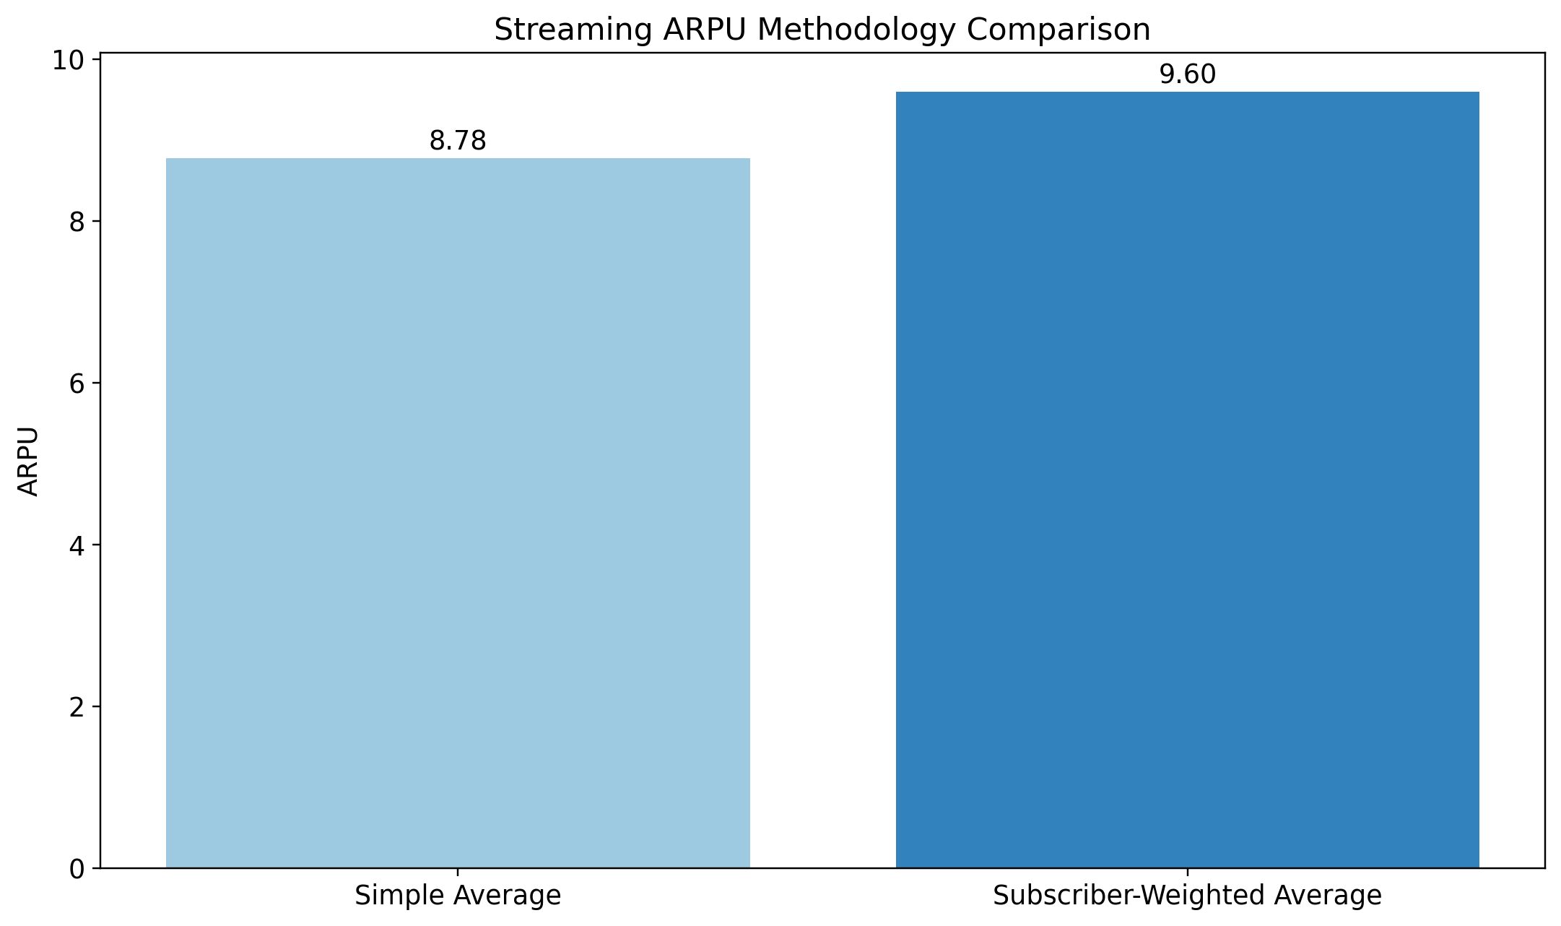
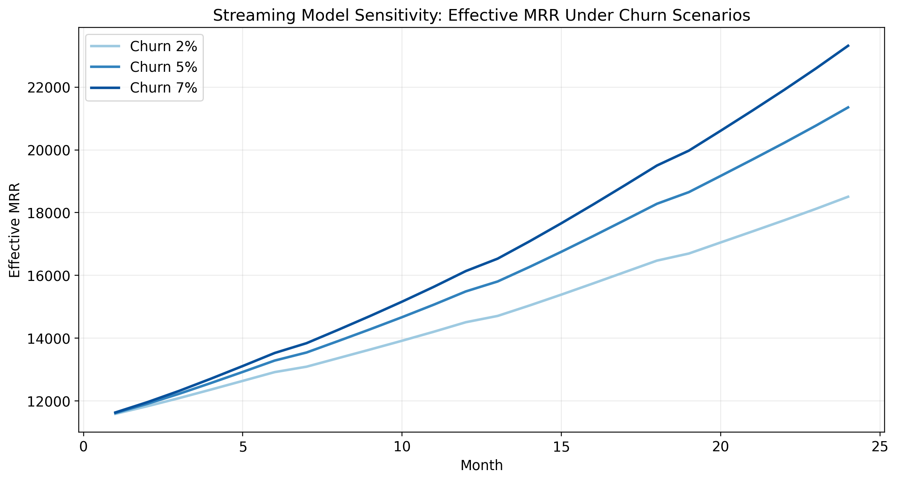
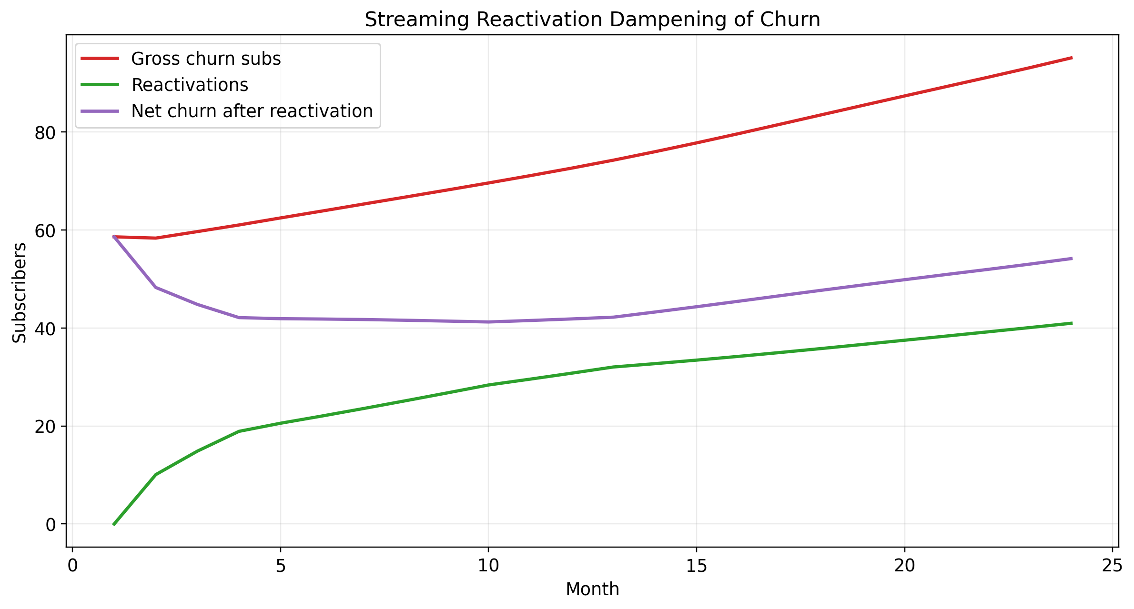

SaaS Model
The SaaS model is an archetype for the $1M-$3M ARR band using public benchmarks only. Starting ARR is set at the midpoint of the band ($2.0M ARR), with monthly ARPA normalized at $1,000 to align to the >$1k ARPA benchmark bucket. This yields approximately 166.67 beginning customers. The model tracks new-logo customers, renewals, churn, reactivations, gross expansion ARR, contraction ARR, dynamic pricing, and independent CAC.
SaaS independent CLV = 28,203.05; independent CAC = 22,096.19; CLV/CAC ratio = 1.28. Monte Carlo uncertainty interval for CLV/CAC ratio: 1.12 to 1.46. This is an uncertainty interval from benchmark distributions, not a claim of exact predictive confidence.

SaaS Benchmark Table
metric | value | source
Gross margin overall median | 0.7200 | KeyBanc/Sapphire overall survey group 2024
Gross margin top quartile | 0.8100 | KeyBanc/Sapphire top quartile 2024
Logo churn monthly median (ARR $1M-$3M) | 0.0130 | ChartMogul customer churn benchmark
Gross MRR churn monthly (> $1k ARPA) | 0.0270 | ChartMogul revenue churn benchmark
Net MRR churn monthly (> $1k ARPA) | 0.0010 | ChartMogul revenue churn benchmark
New customer CAC ratio median | 1.76 | Benchmarkit/Pavilion-type 2024 benchmark summary
New customer CAC ratio top quartile | 2.03 | Benchmarkit/Pavilion-type 2024 benchmark summary
Expansion share of positive ARR movement | 0.2600 | OpenView early-to-mid-stage benchmark context
Private SaaS annual growth median | 0.2000 | High Alpha/OpenView 2024 benchmark context

SaaS Monthly Model (24 months)
Month | Beginning Customers | ARPA Monthly | Beginning ARR | New Logo Customers | New Logo ARR | Voluntary Churn Customers | Involuntary Churn Customers | Gross Logo Churn Customers | Reactivated Customers | Renewals | Gross Expansion ARR | Contraction ARR | Net Expansion ARR | Ending Customers | Ending ARR | Ending MRR | Retention Rate | Net Revenue Churn Rate | NRR | ACV | TCV | Subscription Bookings | CAC per New Customer | Total CAC Spend | Tail Reactivation Reserve
1 | 166.67 | 1,000.07 | 2,000,000 | 2.92 | 35,084 | 1.52 | 0.2700 | 1.79 | 0 | 164.88 | 40,760.53 | 23,744 | 17,016.53 | 167.80 | 2,030,767.19 | 169,230.60 | 0.9893 | 0.0022 | 0.9978 | 12,000.89 | 18,001.33 | 35,084 | 21,121.57 | 61,747.84 | 0.1300
2 | 167.80 | 1,004.15 | 2,013,750.66 | 2.45 | 29,470.84 | 1.47 | 0.2600 | 1.73 | 0.1300 | 166.07 | 41,884.50 | 20,011.41 | 21,873.09 | 168.64 | 2,053,999.92 | 171,166.66 | 0.9897 | -0.0013 | 1.00 | 12,049.78 | 18,074.67 | 29,470.84 | 21,207.62 | 51,868.68 | 0.2600
3 | 168.64 | 1,008.24 | 2,032,126.83 | 2.47 | 29,936.77 | 1.47 | 0.2600 | 1.73 | 0.1800 | 166.91 | 42,284.71 | 20,194.23 | 22,090.48 | 169.56 | 2,073,629.42 | 172,802.45 | 0.9897 | -0.0016 | 1.00 | 12,098.87 | 18,148.31 | 29,936.77 | 21,294.02 | 52,688.72 | 0.3900
4 | 169.56 | 1,012.35 | 2,051,538.94 | 2.47 | 30,016.01 | 1.48 | 0.2600 | 1.74 | 0.2200 | 167.82 | 42,685.20 | 20,387.08 | 22,298.13 | 170.52 | 2,093,747.85 | 174,478.99 | 0.9897 | -0.0019 | 1.00 | 12,148.17 | 18,222.25 | 30,016.01 | 21,380.77 | 52,828.18 | 0.5200
5 | 170.52 | 1,016.47 | 2,071,449.72 | 2.44 | 29,770.71 | 1.49 | 0.2600 | 1.75 | 0.2400 | 168.76 | 43,098.17 | 20,584.91 | 22,513.26 | 171.44 | 2,113,702.08 | 176,141.84 | 0.9897 | -0.0020 | 1.00 | 12,197.66 | 18,296.49 | 29,770.71 | 21,467.88 | 52,396.44 | 0.6400
6 | 171.44 | 1,020.61 | 2,091,188.82 | 2.36 | 28,946.95 | 1.50 | 0.2600 | 1.76 | 0.2500 | 169.68 | 43,510.31 | 20,781.09 | 22,729.22 | 172.29 | 2,132,882.73 | 177,740.23 | 0.9897 | -0.0020 | 1.00 | 12,247.36 | 18,371.03 | 28,946.95 | 21,555.35 | 50,946.63 | 0.7600
7 | 172.29 | 1,024.77 | 2,110,153.51 | 2.26 | 27,741.15 | 1.51 | 0.2700 | 1.77 | 0.2700 | 170.52 | 43,908.77 | 20,969.59 | 22,939.18 | 173.04 | 2,150,913.53 | 179,242.79 | 0.9897 | -0.0021 | 1.00 | 12,297.25 | 18,445.88 | 27,741.15 | 21,643.16 | 48,824.42 | 0.8800
8 | 173.04 | 1,028.95 | 2,127,974.35 | 2.15 | 26,494.38 | 1.51 | 0.2700 | 1.78 | 0.2800 | 171.27 | 44,284.90 | 21,146.76 | 23,138.15 | 173.69 | 2,167,758.92 | 180,646.58 | 0.9897 | -0.0022 | 1.00 | 12,347.35 | 18,521.03 | 26,494.38 | 21,731.34 | 46,630.10 | 1
9 | 173.69 | 1,033.14 | 2,144,620.77 | 2.06 | 25,562.02 | 1.52 | 0.2700 | 1.79 | 0.2900 | 171.91 | 44,636.69 | 21,312.25 | 23,324.44 | 174.26 | 2,183,739.72 | 181,978.31 | 0.9897 | -0.0022 | 1.00 | 12,397.66 | 18,596.49 | 25,562.02 | 21,819.88 | 44,989.16 | 1.12
10 | 174.26 | 1,037.35 | 2,160,415.28 | 2.03 | 25,218.34 | 1.52 | 0.2700 | 1.79 | 0.3100 | 172.47 | 44,969.41 | 21,469.26 | 23,500.15 | 174.80 | 2,199,450.65 | 183,287.55 | 0.9897 | -0.0023 | 1.00 | 12,448.17 | 18,672.25 | 25,218.34 | 21,908.77 | 44,384.27 | 1.24
11 | 174.80 | 1,041.57 | 2,175,950.50 | 2.05 | 25,647.08 | 1.53 | 0.2700 | 1.80 | 0.3100 | 173 | 45,294.30 | 21,623.66 | 23,670.65 | 175.37 | 2,215,602.07 | 184,633.51 | 0.9897 | -0.0024 | 1.00 | 12,498.88 | 18,748.32 | 25,647.08 | 21,998.03 | 45,138.86 | 1.36
12 | 175.37 | 1,045.82 | 2,191,931.42 | 2.13 | 26,707.26 | 1.53 | 0.2700 | 1.80 | 0.3200 | 173.57 | 45,625.62 | 21,782.45 | 23,843.17 | 176.02 | 2,232,829.31 | 186,069.11 | 0.9897 | -0.0024 | 1.00 | 12,549.80 | 18,824.71 | 26,707.26 | 22,087.66 | 47,004.78 | 1.48
13 | 176.02 | 1,045.89 | 2,208,986.14 | 2.59 | 32,552.33 | 1.54 | 0.2700 | 1.81 | 0.3300 | 174.21 | 45,793.59 | 26,237.31 | 19,556.27 | 177.13 | 2,242,685.59 | 186,890.47 | 0.9897 | -0.0004 | 1.00 | 12,550.73 | 18,826.10 | 32,552.33 | 22,089.29 | 57,292.11 | 1.49
14 | 177.13 | 1,050.16 | 2,223,129.31 | 2.36 | 29,736.88 | 1.55 | 0.2700 | 1.82 | 0.3300 | 175.31 | 46,247.61 | 22,092.11 | 24,155.50 | 178 | 2,267,267.03 | 188,938.92 | 0.9897 | -0.0024 | 1.00 | 12,601.87 | 18,902.80 | 29,736.88 | 22,179.29 | 52,336.91 | 1.49
15 | 178 | 1,054.43 | 2,243,111.53 | 2.45 | 30,940.15 | 1.56 | 0.2700 | 1.83 | 0.3300 | 176.17 | 46,676.04 | 22,290.85 | 24,385.19 | 178.94 | 2,288,613.22 | 190,717.77 | 0.9897 | -0.0024 | 1.00 | 12,653.21 | 18,979.81 | 30,940.15 | 22,269.65 | 54,454.67 | 1.50
16 | 178.94 | 1,058.73 | 2,264,228.03 | 2.49 | 31,579.09 | 1.56 | 0.2800 | 1.84 | 0.3300 | 177.10 | 47,111.67 | 22,500.65 | 24,611.02 | 179.92 | 2,310,494.36 | 192,541.20 | 0.9897 | -0.0024 | 1.00 | 12,704.76 | 19,057.14 | 31,579.09 | 22,360.38 | 55,579.20 | 1.51
17 | 179.92 | 1,063.04 | 2,285,883.34 | 2.47 | 31,482.46 | 1.57 | 0.2800 | 1.85 | 0.3400 | 178.07 | 47,560.86 | 22,715.83 | 24,845.03 | 180.88 | 2,332,188.63 | 194,349.05 | 0.9897 | -0.0024 | 1.00 | 12,756.52 | 19,134.78 | 31,482.46 | 22,451.48 | 55,409.13 | 1.51
18 | 180.88 | 1,067.37 | 2,307,343.60 | 2.40 | 30,721.53 | 1.58 | 0.2800 | 1.86 | 0.3400 | 179.01 | 48,008.98 | 22,929.11 | 25,079.87 | 181.75 | 2,353,029.54 | 196,085.80 | 0.9897 | -0.0024 | 1.00 | 12,808.49 | 19,212.74 | 30,721.53 | 22,542.95 | 54,069.89 | 1.52
19 | 181.75 | 1,071.72 | 2,327,949.67 | 2.30 | 29,547.91 | 1.59 | 0.2800 | 1.87 | 0.3400 | 179.88 | 48,441.99 | 23,133.94 | 25,308.05 | 182.52 | 2,372,606.18 | 197,717.18 | 0.9897 | -0.0024 | 1.00 | 12,860.68 | 19,291.01 | 29,547.91 | 22,634.79 | 52,004.32 | 1.53
20 | 182.52 | 1,076.09 | 2,347,298.13 | 2.19 | 28,332.29 | 1.60 | 0.2800 | 1.88 | 0.3400 | 180.64 | 48,850.44 | 23,326.29 | 25,524.15 | 183.18 | 2,390,880.52 | 199,240.04 | 0.9897 | -0.0024 | 1.00 | 12,913.07 | 19,369.61 | 28,332.29 | 22,727.01 | 49,864.84 | 1.53
21 | 183.18 | 1,080.47 | 2,365,356.37 | 2.12 | 27,463.06 | 1.60 | 0.2800 | 1.88 | 0.3400 | 181.29 | 49,232.13 | 23,505.82 | 25,726.31 | 183.75 | 2,408,204.06 | 200,683.67 | 0.9897 | -0.0024 | 1.00 | 12,965.68 | 19,448.52 | 27,463.06 | 22,819.60 | 48,334.98 | 1.54
22 | 183.75 | 1,084.88 | 2,382,477.75 | 2.09 | 27,239.57 | 1.60 | 0.2800 | 1.89 | 0.3400 | 181.86 | 49,592.86 | 23,676.02 | 25,916.84 | 184.30 | 2,425,227.39 | 202,102.28 | 0.9897 | -0.0024 | 1.00 | 13,018.51 | 19,527.76 | 27,239.57 | 22,912.57 | 47,941.65 | 1.55
23 | 184.30 | 1,089.30 | 2,399,310.55 | 2.13 | 27,789.41 | 1.61 | 0.2800 | 1.89 | 0.3400 | 182.41 | 49,944.94 | 23,843.32 | 26,101.61 | 184.88 | 2,442,726.88 | 203,560.57 | 0.9897 | -0.0024 | 1.00 | 13,071.54 | 19,607.32 | 27,789.41 | 23,005.92 | 48,909.36 | 1.55
24 | 184.88 | 1,093.73 | 2,416,625.26 | 2.21 | 29,033.01 | 1.61 | 0.2800 | 1.90 | 0.3500 | 182.98 | 50,303.91 | 24,015.37 | 26,288.54 | 185.53 | 2,461,396.36 | 205,116.36 | 0.9897 | -0.0024 | 1.00 | 13,124.80 | 19,687.20 | 29,033.01 | 23,099.65 | 51,098.11 | 1.56

SaaS CLV/CAC Uncertainty Interval
Metric | Mean | P05 | P95
CLV | 27,956.08 | 23,869.78 | 32,690.90
CAC | 21,913.85 | 18,426.26 | 25,778.40
CLV/CAC Ratio | 1.28 | 1.12 | 1.46

SaaS Scenario Analysis
Scenario | Logo Churn Input | Annual Price Growth | Month24 ARR | Month24 MRR | Avg Retention Rate | Avg NRR | Avg CAC per New Customer
logo_churn_1.0%_price_3.0% | 0.0100 | 0.0300 | 2,371,256.35 | 197,604.70 | 0.9897 | 1.00 | 21,652.73
logo_churn_1.0%_price_5.0% | 0.0100 | 0.0500 | 2,461,396.36 | 205,116.36 | 0.9897 | 1.00 | 22,096.19
logo_churn_1.0%_price_8.0% | 0.0100 | 0.0800 | 2,599,603.97 | 216,633.66 | 0.9897 | 1.00 | 22,767.30
logo_churn_1.3%_price_3.0% | 0.0130 | 0.0300 | 2,371,256.35 | 197,604.70 | 0.9897 | 1.00 | 21,652.73
logo_churn_1.3%_price_5.0% | 0.0130 | 0.0500 | 2,461,396.36 | 205,116.36 | 0.9897 | 1.00 | 22,096.19
logo_churn_1.3%_price_8.0% | 0.0130 | 0.0800 | 2,599,603.97 | 216,633.66 | 0.9897 | 1.00 | 22,767.30
logo_churn_1.6%_price_3.0% | 0.0160 | 0.0300 | 2,371,256.35 | 197,604.70 | 0.9897 | 1.00 | 21,652.73
logo_churn_1.6%_price_5.0% | 0.0160 | 0.0500 | 2,461,396.36 | 205,116.36 | 0.9897 | 1.00 | 22,096.19
logo_churn_1.6%_price_8.0% | 0.0160 | 0.0800 | 2,599,603.97 | 216,633.66 | 0.9897 | 1.00 | 22,767.30

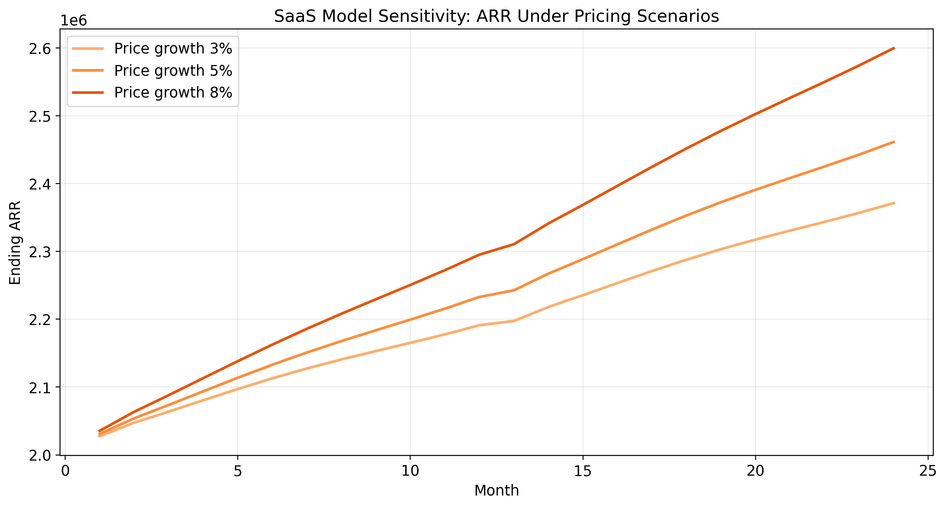
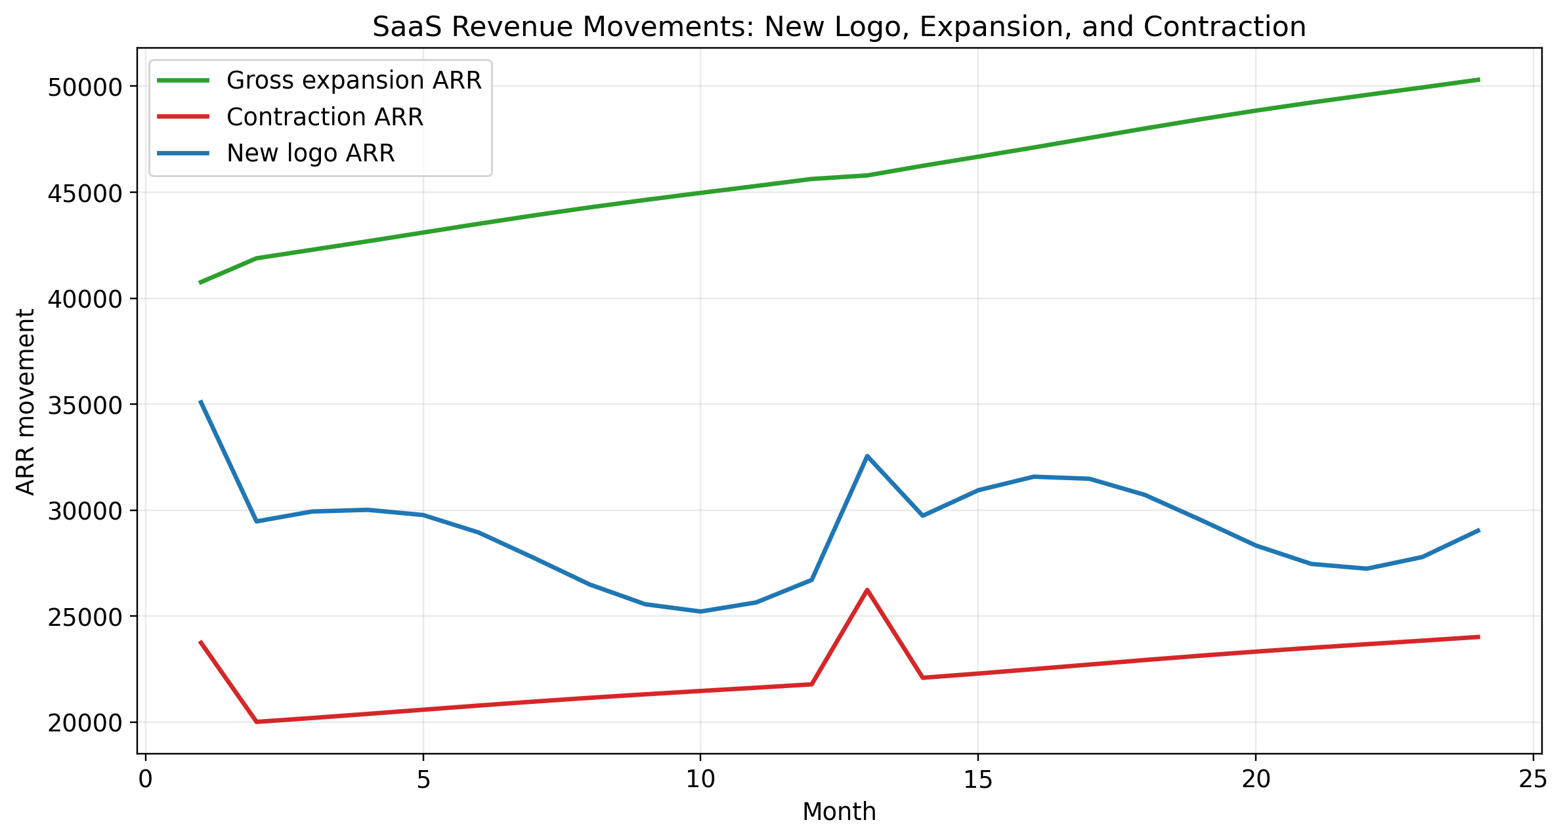
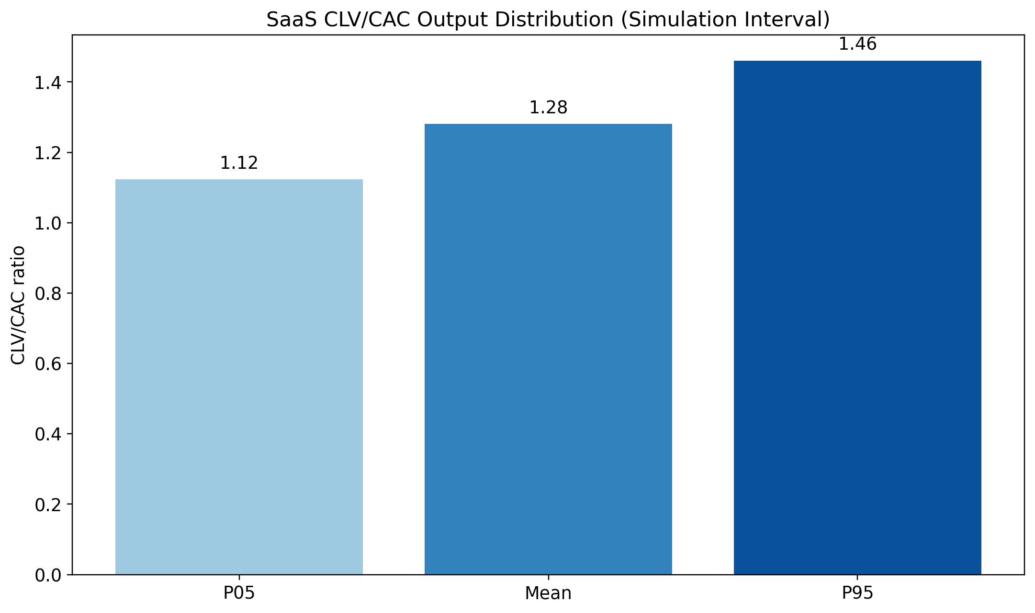

How the 17 Audit Findings Were Addressed
Issue ID | Audit Issue | Status | Response
1 | Circular CLV/CAC construction | Fixed | SaaS CAC now calculated independently from new-customer CAC ratio; CLV calculated from churn, margin, ARPA, and discounting; ratio is output with simulation interval.
2 | Constant acquisition rate | Fixed | Both models use dynamic acquisition tied to benchmark growth, seasonality, and maturity/saturation effects.
3 | Billing leakage uncertainty undisclosed | Fixed | Leakage now disclosed as 2% / 4.59% / 8% low-base-high scenarios with derivation shown.
4 | ARPU averaging weak | Fixed | Streaming ARPU now uses subscriber-weighted average and documents simple-average comparison.
5 | Expansion disconnected from installed base | Fixed | Expansion now applies to retained/reactivated installed base in both models.
6 | Reactivation not segmented by churn type | Fixed | Voluntary and involuntary churn pools use different recovery curves.
7 | No feedback loops | Fixed | Churn now affects CAC in SaaS; expansion improves retention; reactivation pools deplete over time.
8 | Static churn rate regardless of mix | Fixed | New, retained, and reactivated cohorts carry different churn rates.
9 | Seat factor non-functional | Fixed by exclusion | Removed due to insufficient confidence; exclusion disclosed.
10 | Beginning subscribers unexplained | Fixed | Streaming beginning subscribers derived from rate-card MRR / weighted ARPU; SaaS beginning customers derived from ARR-band archetype / ARPA.
11 | Churn sensitivity not quantified | Fixed | Scenario tables for low/base/high churn and downstream metrics included.
12 | Reactivation dampening nonlinear effect unquantified | Fixed | Reactivation dampening percentage is now tracked monthly and summarized.
13 | Expansion insensitive to dynamics | Fixed | Expansion now responds to installed base composition and business maturity.
14 | Multi-cycle reactivation not addressed | Fixed | Repeat churn pools and repeat-reactivation logic added.
15 | Truncated reactivation windows | Fixed with limitation note | Forecast extended to 24 months and tail reactivation reserve disclosed for unresolved windows.
16 | No contraction / downgrade modeling | Fixed | Streaming promotional dilution and SaaS contraction ARR now explicitly modeled.
17 | No pricing sensitivity | Fixed | Dynamic ARPU/ARPA with price growth and promo periods added; scenarios include pricing variation.

Key Assumptions, Uncertainties, and Limitations
- The streaming model remains benchmark-calibrated rather than company-specific. It should be interpreted as a defensible planning model, not a direct substitute for first-party billing and event data.
- The SaaS model is an archetype for the $1M-$3M ARR band, not a company-specific forecast. Absolute outputs should be interpreted relative to that archetype.
- Forecast accuracy declines with horizon. Months 13-24 are useful for structural direction and steady-state effects, but less reliable than the first 12 months.
- Scenario bands are uncertainty bands. They should not be called statistical confidence intervals unless they are tied to formal probabilistic calibration.
- Excluded metrics were removed because confidence was below acceptable standards, consistent with the user instruction to exclude weak metrics.

